**GMAT9600 Assignment – Optical Application**

**Monitoring the 2009 Victorian Bushfires with**

**Optical Satellite Remote Sensing**

DISCLAIMER

Satellite imagery provided for this assignment is for teaching GMAT9600 ONLY and hence should not be used for any other purpose. Students should delete the satellite imagery from their storage as soon as the assignment is submitted.

1. **Background**

On Saturday 7th February 2009, the worst bushfires in Australia’s history occurred in Victoria. It lasted for weeks and 173 people were reported dead. The serious brushfires also destroyed at least 1834 homes, leaving estimated 7500 people homeless.

Since the area of the bushfires were extremely large, almost the entire Victoria had been impacted, it was very difficult for traditional monitoring methods to locate regions that had the most serious situation and to discover new fire spots. In contrast, the spaceborne remote sensing methods which provide large coverage imagery can easily overcome the problem. Based on this consideration, the GEOS group of UNSW utilised data from China’s HJ satellite constellation (Environmental Monitoring and Disaster Mitigation) to extract the bushfire fronts, assisting the corresponding departments of the Victorian government in the emergency response.

The purpose of this assignment is to use a subset of the same dataset used for this event by GEOS and try to identify and visualise the locations of bushfires. Comparison to other optical remote sensing data is also required in order to make a clear sense of what kind of dataset is the best for bushfire identification.

1. **HJ Satellites**

China’s HJ satellite constellation is a spaceborne Earth observation system. It is composed of three small satellites. Two of them are optical satellites (HJ-1A and HJ-1B) which were launched on 6th September 2008, and the other one is a Radar satellite. The detailed information of HJ-1A and HJ-1B is listed in Table 1.

Table 1. Parameters of HJ-1A and HJ-1B

|  |  |  |  |  |  |  |
| --- | --- | --- | --- | --- | --- | --- |
| **Satellite** | **Sensor** | **Band ID** | **Bandwidth (µm)** | **Spatial Resolution (m)** | **Swath Width (km)** | **Revisit Time (day)** |
| HJ-1A | CCD Camera | 1 | 0.43-0.52 | 30 | 360 (single camera)，700 (double cameras) | 4 |
| 2 | 0.52-0.60 | 30 |
| 3 | 0.63-0.69 | 30 |
| 4 | 0.76-0.90 | 30 |
| HJ-1B | CCD Camera | 1 | 0.43-0.52 | 30 | 360 (single camera), 700 (double cameras) | 4 |
| 2 | 0.52-0.60 | 30 |
| 3 | 0.63-0.69 | 30 |
| 4 | 0.76-0.90 | 30 |
| Infrared Camera | 5 | 0.75-1.10 | 150 | 720 | 4 |
| 6 | 1.55-1.75 |
| 7 | 3.50-3.90 |
| 8 | 10.5-12.5 | 300 |

In the area of optical remote sensing, bands (or channels) of a sensor normally have individual names and can be used for relevant applications. The channel names and the major targeted applications for HJ-1A and HJ-1B are listed in Table 2.

Table 2. Channel information of HJ-1A and HJ-1B

|  |  |  |
| --- | --- | --- |
| **Band range (µm)** | **Channel Name** | **Applications** |
| 0.43-0.52 | Blue | Waterbody detection |
| 0.52-0.60 | Green | Vegetation coverage |
| 0.63-0.69 | Red | Land features |
| 0.76-0.90 | Near Infrared | Soil humidity, water boundary and vegetation |
| 0.75-1.10 | Near Infrared | Water boundary, farmland and land features |
| 1.55-1.75 | Shortwave Infrared | Soil classification, cloud and snow area |
| 3.50-3.90 | Mid Infrared | Radiation from high temperature objects, feature identification at night |
| 10.5-12.5 | Thermal | Radiation from objects with normal temperature, feature identification at night |

By using images from a certain band of HJ satellites or combining some bands, the bushfires could be observed.

1. **Description of the Experimental Imagery**

To identify the bushfires that started on 7th February 2009, a group of HJ-1B data acquired on day later on 8th February 2009 was used. Data from both the CCD camera and the infrared camera will be provided.

The last number of the file names indicates the band ID of the HJ data. For example, “HJ1B-CCD2-400-166-20090208-L20000065990-2-M.tif” is the image file for CCD band 2 and “HJ1B-IRS-398-168-20090208-L20000065593-1-M.tif” is from Infrared band 1 which is the 5th band according to Table 1.

Meanwhile, in order to show the advantages of using HJ data to identify bushfires, data from MODIS satellite which was acquired on the same day (8th February 2009) will be provided for comparison. MODIS is a multi-spectrum optical satellite sensor. It provides images from 36 bands. In this experiment, only seven bands are useful and their detailed information is given in Table 3. For introductions of other bands, please refer to <http://modis.gsfc.nasa.gov/about/specifications.php>.

Table 3. Band Information of MODIS Data

|  |  |  |  |  |  |
| --- | --- | --- | --- | --- | --- |
| **Band ID** | **Subset Data ID** | **Band Name in Subset** | **Bandwidth (µm)** | **Spatial Resolution (m)** | **Primary Use** |
| 1 | subsetdata 4 | Band_1 | 0.620 – 0.670 | 250 | Land/Cloud/Aerosols Boundaries |
| 2 | Band_2 | 0.841 – 0.876 |
| 3 | subsetdata 7 | Band_1 | 0.459 – 0.479 | 500 | Land/Cloud/Aerosols Properties |
| 4 | Band_2 | 0.545 – 0.565 |
| 5 | Band_3 | 1.230 – 1.250 |
| 6 | Band_4 | 1.628 – 1.652 |
| 7 | Band_5 | 2.105 – 2.155 |

In this experiment, the key analysing method is to observe images from each band of HJ-1B and to colour-code multiple bands to make the bushfire areas distinct. Therefore, choosing appropriate bands is very important here. Please refer to Table 1 to Table 3 for data selection.

1. **Guidelines for Data Processing**

Students will use ArcGIS software to process the data. The two major components of the software are ArcMap and ArcCatalog. To launch ArcMap, go to “Start >> Programs >> ArcGIS >> ArcMap 10”. In the same menu, the shortcut of “ArcCatalog 10” can be found as well. The workspace of ArcMap and ArcCatalog are shown in Fig 1 and Fig 2 respectively.

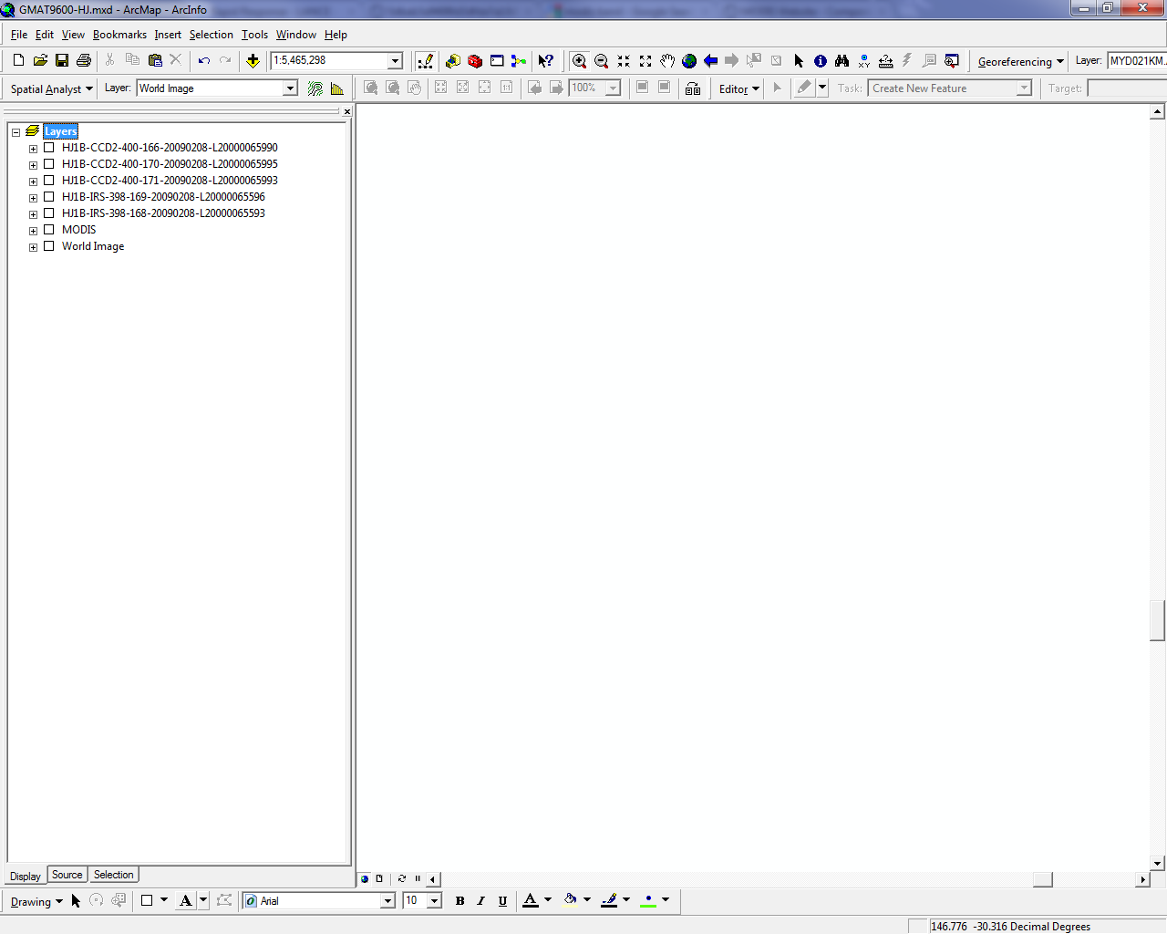

Fig 1. The Window of ArcMap Software

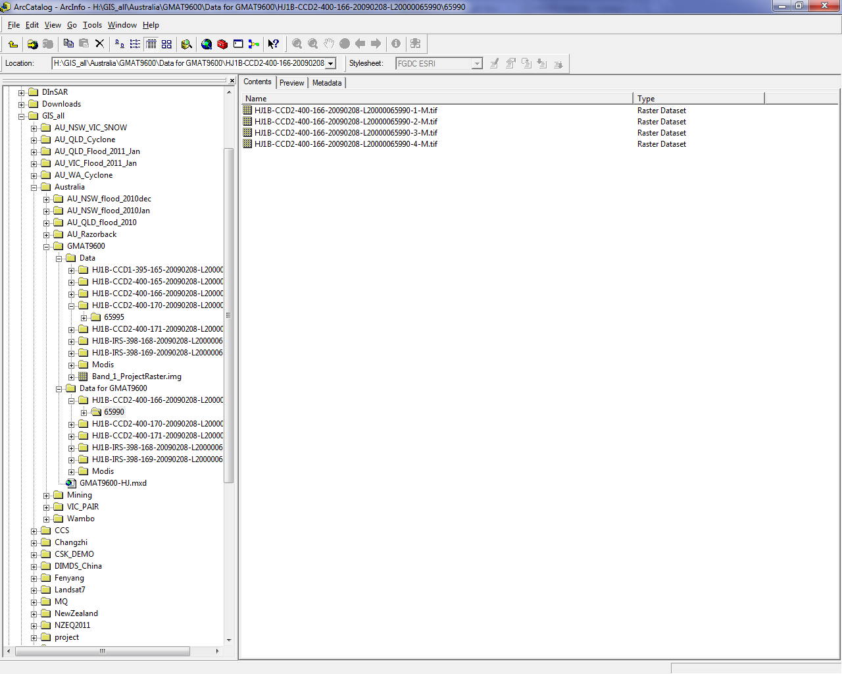

Fig 2. The Window of ArcCatalog Software

ArcMap is a workspace for viewing and processing image data. To start image analysis, the first step is to set the coordinate system so that the data with geo-coordinate information can be displayed correctly. Right click “Layers” in the left sub-window of ArcMap and then select “Properties”. A dialog as shown in Fig 3 will pop out. The “Coordinate System” tab can be set to either the WGS-84 coordinate system or its projection “UTM Zone 55S”. WGS-84 can be found in “Predefined >> Geographic Coordinate Systems >> World” and UTM Zone 55S is in “Predefined >> Projected Coordinate Systems >> UTM >> WGS 1984”.

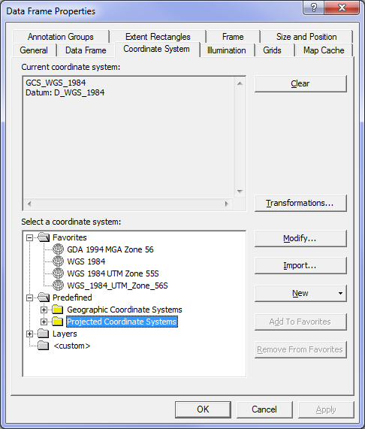

Fig 3. Setting Coordinate Systems of a Workspace

To add data into ArcMap, go to ArcCatalog. Browse the “Location” to find data in corresponding folders. Make sure that each data has been assigned to a correct coordinate system. It can be found by right clicking the data and then selecting “Properties” in the menu. An example Properties window is given in Fig 4. In this window, detailed information of the data can be found, including the data size in “Columns and Rows”, the spatial resolution in “Cellsize (X, Y)” and the coordinate information in “Spatial Reference”. If the information of provided data is correct, simply drag it from ArcCatalog to ArcMap to display.

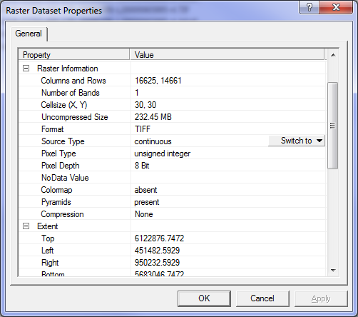

Fig 4. “Properties” Window of a Data

Once a data has been added to ArcMap, you can tick on or off the checkbox on the left to enable or disable the display. It is very useful while comparing multiple images for the same location. You can also zoom in or zoom out an image by the magnifier icons  in the toolbar to see the details or the overview.

After several bands of a dataset are added to ArcMap, you can implement the colour composition. It is a useful tool for highlighting certain ground features. Click the red box button  in the toolbar to enable the ArcMap toolbox. Go to “Data Management Tools” >> “Raster” >> “Raster Processing”, and then click the “Composite Bands” tag. The toolbox of “Composite Bands” shown as Fig 5 will pop up.

Select “Input Rasters” for colour composition and then adjust the orders of selected bands. The first raster (top to bottom) will be represented in Red colour and the second shown as Green with the third one Blue. Therefore, if the RGB colours are assigned with images from Red, Green and Blue bands, a result called true-colour image can be obtained. Otherwise, the composed data are named false-colour images.

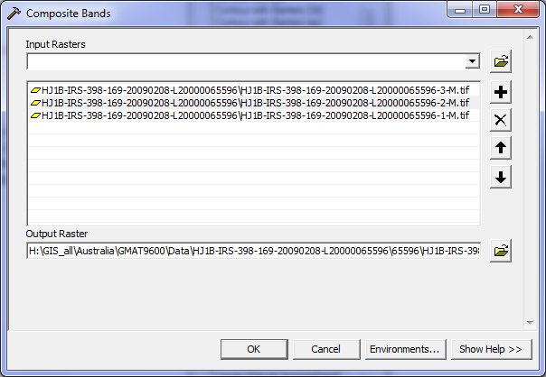

Fig 5. Composite Bands Toolbox

1. **Activities and Quiz Student Name: ID:**
   1. Add all HJ and MODIS data into ArcMap and compare the difference between them. Refer to the “Raster Dataset Properties” for detailed information.

Questions: The CCD images of HJ-1B were taken at the same time of its infrared images. Why their spatial coverage is not the same? Why the coverage of infrared images is larger?

* 1. Produce true colour images for both HJ CCD data and MODIS images.

Questions: What is the band combination of true colour images for HJ and MODIS? What is the key problem of identifying bushfires from these images directly?

* 1. Try to find out bushfires by observing each band of HJ data or combining different bands for true-colour and false-colour results.

Questions: How can you identify the bushfires? What is the principle of your method?

1. **Group Arrangement:**

The Computer Lab in the Civil Engineering Building Lab 201 will be used for the assignment. There will be enough computers in the lab for every student. Each student will be allocated with one computer. It is important that each student has to complete the assignment by himself/herself.

1. **Rules for submitting the Lab Reports and Assignments**

* The lab reports and assignments need to be submitted by email. (For the student in GMAT9600, email to GMAT9600@geos.org.au)
* Only one file per assignment in Word format.
* Name your file as "StudentID-YourLastName-CoureID-assignment.doc". (For example: *z3012345-Charlton-GMAT9600-* *assignment1.doc*).
* Your email must have your name, student ID and the assignment name in the subject.
* Do NOT send multiple submissions for the same assignment. If you have to re-submit, you need to request permission from the course convenor.
* ***NOTE:******Failing to submit the file with correct format and/or naming convention will result in deduction of 1 mark.***

1. **Performance Evaluation:**

It is important for each student to complete activities and answer questions given in Section 5 and show them to the lab supervisor. The following marks will be given by the lab:

* Activity “a” and related quiz (5 marks)
* Activity “b” and related quiz (8 marks)
* Activity “c” and related quiz (12 marks)